5_5.R

Tyler Brandt

Tue Mar 13 15:03:33 2018

data = read.csv("C:/Users/Tyler Brandt/Desktop/Math-336/Homework 2/5_5.csv")  
  
pac_indx = which(data[,1]>-20 & data[,1]<20 & data[,2]>160 & data[,2]<260)  
cleaned_data = data[pac_indx, 54:103] #1951-2000  
  
svd = svd(cleaned_data)  
U=svd$u  
D=svd$d  
V=svd$v  
  
#a  
D[1:10]

## [1] 72.444123 33.427823 16.920088 13.001594 11.892679 10.363222 8.450116  
## [8] 7.947628 6.872261 6.375350

#b  
x <- 1:20 #100 degrees change in long/ 5 degree steps  
y <- 1:8 #40 degrees change in lat/ 5 degree steps  
plot.new() #start a new figure from blank  
par(mar=c(5,5,2,1))  
filled.contour(x, y, matrix(U[,1], ncol = 8),   
 key.title = title(main = "Scale"),  
 plot.axes = {axis(1,seq(1,20, length = 6), cex.axis=1.3, labels = c(160, 180, -160, -140, -120, -100))   
 axis(2,at = seq(1,8, length=9), cex.axis=1.3, labels = c('-20','-15','-10','-5','0','5','10','15','20'))},  
 plot.title = title(main = "Spatial pattern (EOF): Pacific 1951",  
 xlab="Longitude",  
 ylab="Latitude", cex.lab=1.5),  
 color.palette = colorRampPalette(c("red", "white", "blue")))

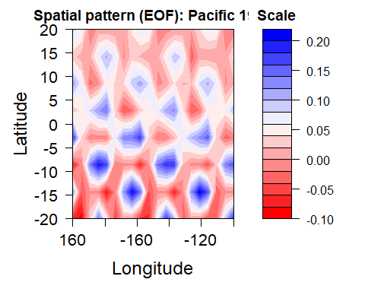

par(mar=c(5,5,2,1))  
filled.contour(x, y, matrix(U[,2], ncol = 8),   
 key.title = title(main = "Scale"),  
 plot.axes = {axis(1,seq(1,20, length = 6), cex.axis=1.3, labels = c(160, 180, -160, -140, -120, -100))   
 axis(2,at = seq(1,8, length=9), cex.axis=1.3, labels = c('-20','-15','-10','-5','0','5','10','15','20'))},  
 plot.title = title(main = "Spatial pattern (EOF): Pacific 1952",  
 xlab="Longitude",  
 ylab="Latitude", cex.lab=1.5),  
 color.palette = colorRampPalette(c("red", "white", "blue")))

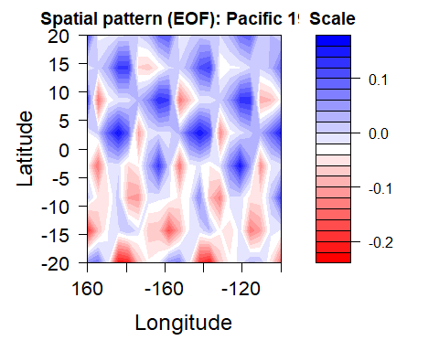

par(mar=c(5,5,2,1))  
filled.contour(x, y, matrix(U[,3], ncol = 8),   
 key.title = title(main = "Scale"),  
 plot.axes = {axis(1,seq(1,20, length = 6), cex.axis=1.3, labels = c(160, 180, -160, -140, -120, -100))   
 axis(2,at = seq(1,8, length=9), cex.axis=1.3, labels = c('-20','-15','-10','-5','0','5','10','15','20'))},  
 plot.title = title(main = "Spatial pattern (EOF): Pacific 1953",  
 xlab="Longitude",  
 ylab="Latitude", cex.lab=1.5),  
 color.palette = colorRampPalette(c("red", "white", "blue")))

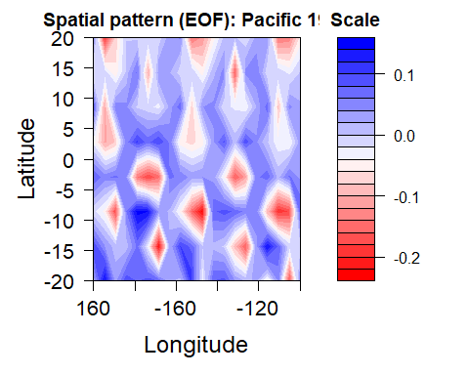

#c  
par(mfrow=c(1,1))  
par(mar=c(5,4,2,1))  
plot(1:50, V[,1],type="o",col="red",lwd=2,  
 main="Temporal Pattern (Principal Components): Time series 1",xlab="Time (Years)",  
 ylab="PC1 values: dimensionless",  
 cex.lab=1.3, cex.axis=1.3)

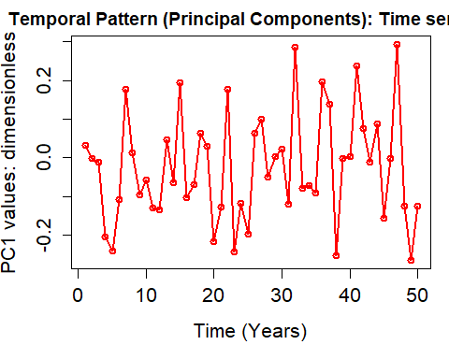

par(mfrow=c(1,1))  
par(mar=c(5,4,2,1))  
plot(1:50, V[,2],type="o",col="red",lwd=2,  
 main="Temporal Pattern (Principal Components): Time series 2",xlab="Time (Years)",  
 ylab="PC2 values: dimensionless",  
 cex.lab=1.3, cex.axis=1.3)

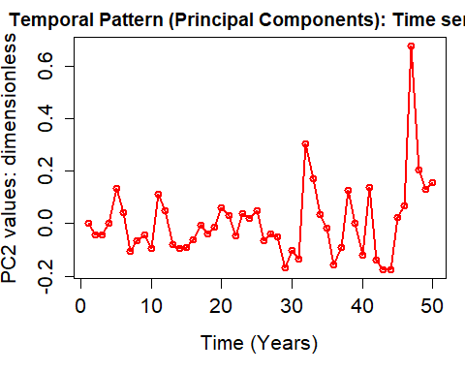

par(mfrow=c(1,1))  
par(mar=c(5,4,2,1))  
plot(1:50, V[,3],type="o",col="red",lwd=2,  
 main="Temporal Pattern (Principal Components): Time series 3",xlab="Time (Years)",  
 ylab="PC3 values: dimensionless",  
 cex.lab=1.3, cex.axis=1.3)

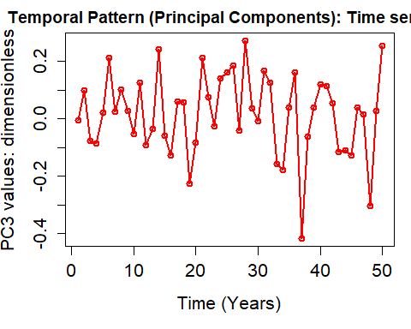

#d  
library(maps)  
Lat=seq(-17.5,17.5, by=5)  
Lon=seq(162.5, 257.5, by=5)  
par(mar=c(4,5,3,0))  
mapmat=matrix(cleaned_data[,1], nrow=20)  
int=seq(-5,5,length.out=81)  
rgb.palette=colorRampPalette(c('black','blue', 'darkgreen',  
 'green', 'yellow','pink','red','maroon'),interpolate='spline')  
  
filled.contour(Lon, Lat, mapmat, color.palette=rgb.palette, levels=int,  
 xlim=c(120,300),ylim=c(-40,40),  
 plot.title=title(main="Pacific Precipitation [in]: Annual 1951",  
 xlab="Latitude",ylab="Longitude", cex.lab=1.5),  
 plot.axes={axis(1, cex.axis=1.5); axis(2, cex.axis=1.5);  
 map('world2', add=TRUE);grid()},  
 key.title=title(main="[oC]"),  
 key.axes={axis(4, cex.axis=1.5)})

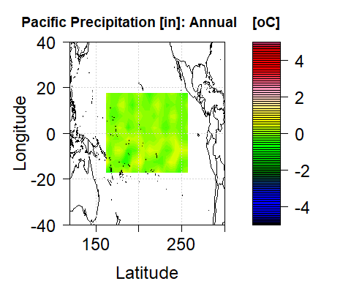

par(mar=c(4,5,3,0))  
mapmat=matrix(cleaned_data[,2], nrow=20)  
filled.contour(Lon, Lat, mapmat, color.palette=rgb.palette, levels=int,  
 xlim=c(120,300),ylim=c(-40,40),  
 plot.title=title(main="Pacific Precipitation [in]: Annual 1952",  
 xlab="Latitude",ylab="Longitude", cex.lab=1.5),  
 plot.axes={axis(1, cex.axis=1.5); axis(2, cex.axis=1.5);  
 map('world2', add=TRUE);grid()},  
 key.title=title(main="[oC]"),  
 key.axes={axis(4, cex.axis=1.5)})

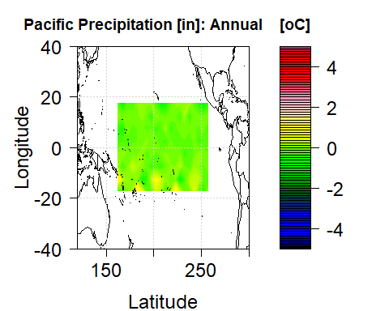

par(mar=c(4,5,3,0))  
mapmat=matrix(cleaned_data[,3], nrow=20)  
filled.contour(Lon, Lat, mapmat, color.palette=rgb.palette, levels=int,  
 xlim=c(120,300),ylim=c(-40,40),  
 plot.title=title(main="Pacific Precipitation [in]: Annual 1953",  
 xlab="Latitude",ylab="Longitude", cex.lab=1.5),  
 plot.axes={axis(1, cex.axis=1.5); axis(2, cex.axis=1.5);  
 map('world2', add=TRUE);grid()},  
 key.title=title(main="[oC]"),  
 key.axes={axis(4, cex.axis=1.5)})

